HOSPITAL- MANAGEMENT- SYSTEM

User Manual



Conventions Followed …

This project follows some conventions throughout say for displaying error messages, for showing searched data,etc.

1. Error Message

On entry of any invalid entry or click an error message is displayed in red as shown in the picture below.

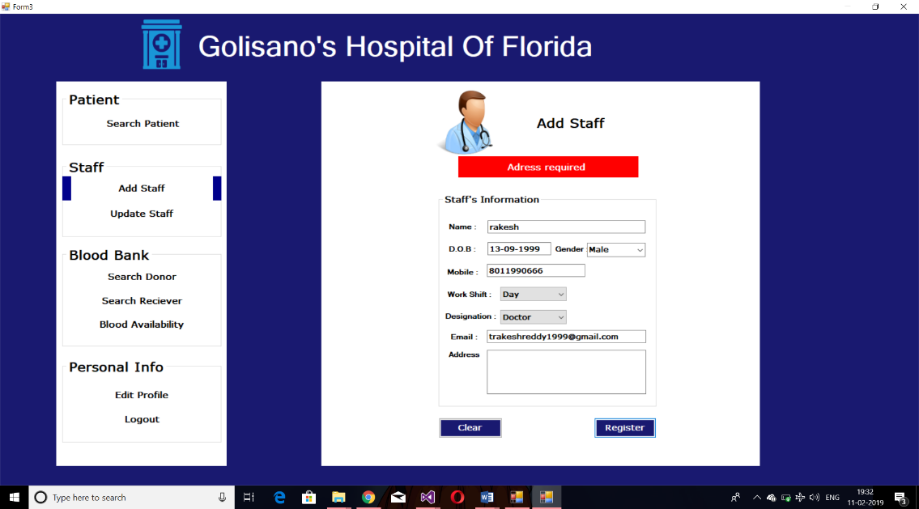

An Example of Error Message

2.Success Message

Similar to error messages the success messages are shown in green.

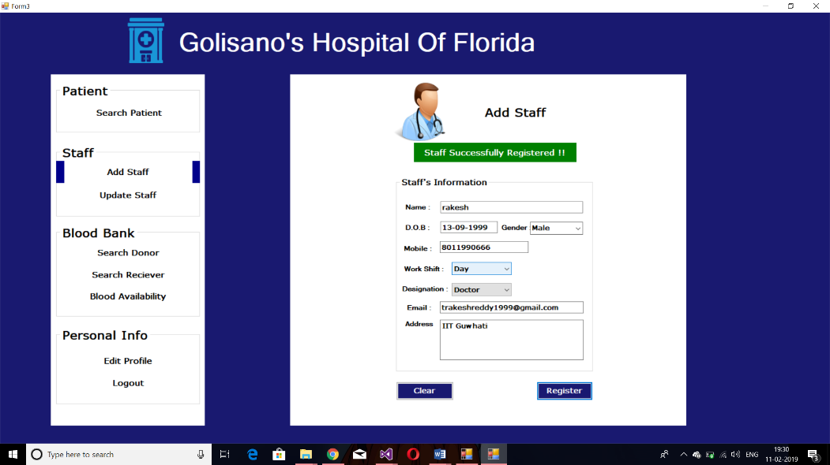

An Example of Success Message

3.Searched Data

The Searched Data is first displayed in data grid (sometimes multi rows present for entries with same searching field). Then on clicking on any cells of the row, the data in corresponding rows are also shown in the textboxes for the user to update/delete data according to the permissions for the user and the options available.

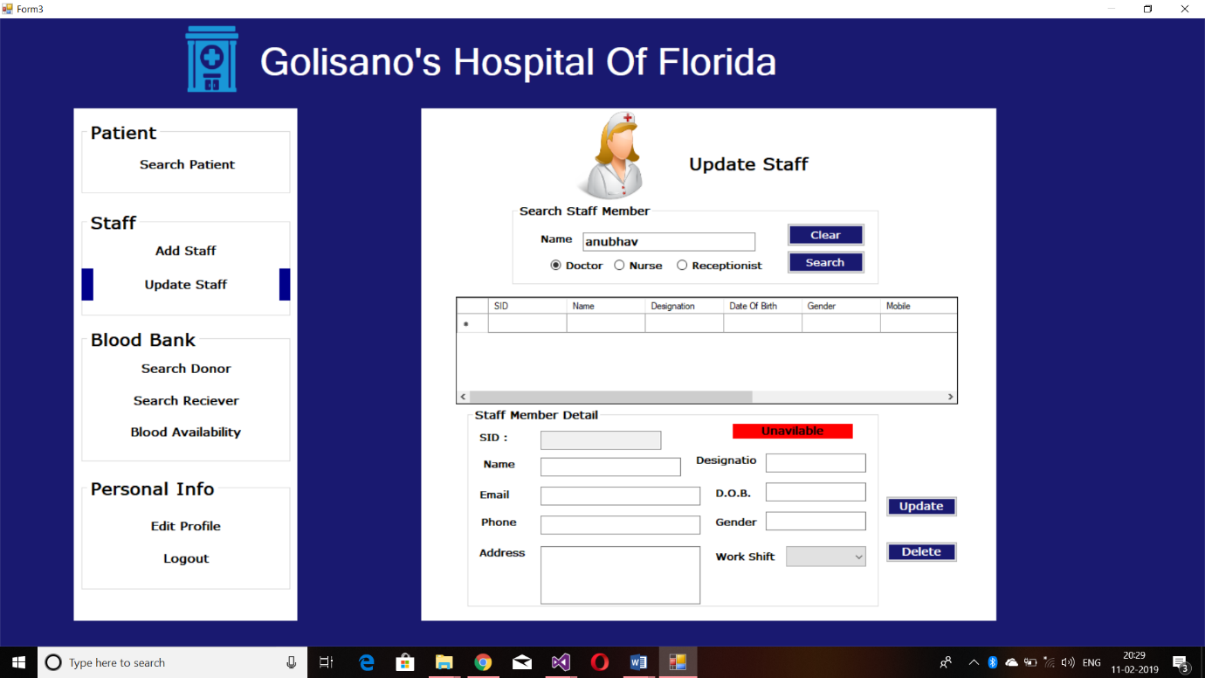

On cell Click the data is displayed here

Data Grid

Gosilano’s Hospital of Florida.

1.Introduction…

The Software is designed for the aid in management of hospital. this software the hospital management can Register the patients along with assigning them tokens for consultation and admitting /discharging them. The software also allows to check the availability of staff members. From here the blood bank department can also be handled with ease. The admin has the power to access all databases at his will.

2.Login..

The Software starts with Login Page, allowing the access to either staff or admin , asking the user for credentials.

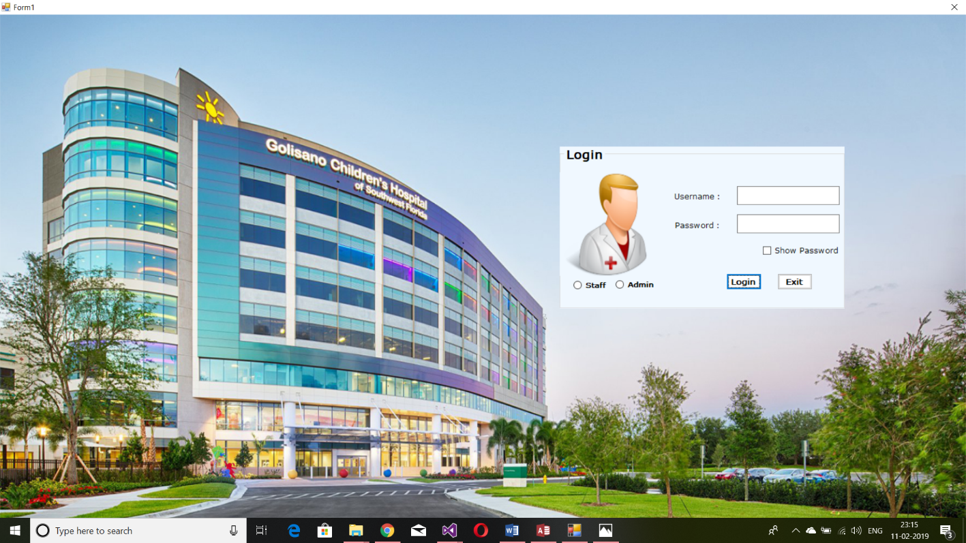

3.Staff Login Features…

3.1 Registration:

Registration page is used to register a new patient. This page comprises of Name, Age, Gender, Mobile, Address fields.

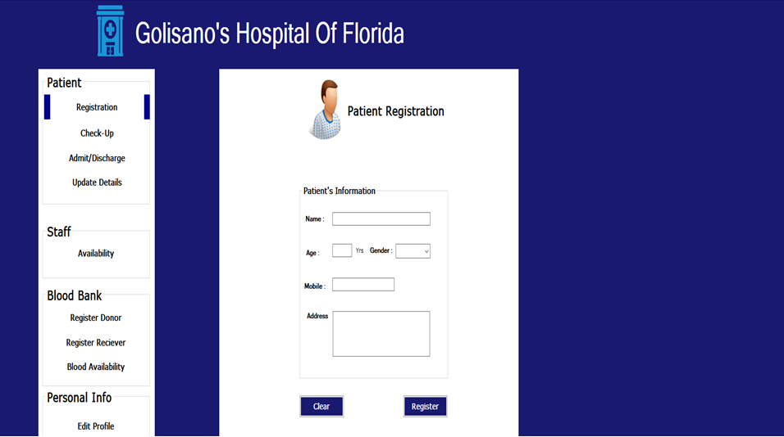

Registration tab button

Register button to register patient

Clear button clears all the fields.

3.2 Check-Up

This page provides feature for use to see the consultation details of patient. 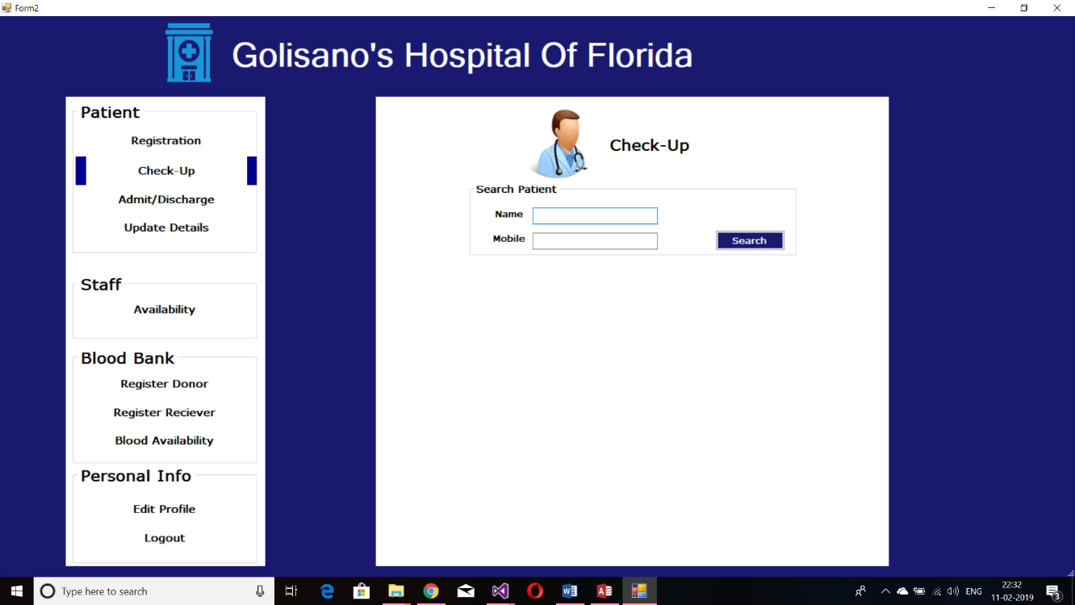

Search button For patient details

The user has to search patient’s details with his name and phone no. On clicking the search button the data is displayed according to the convention mentioned at the start. The clear button clears the texts shown below. Print button prints the payment receipt.

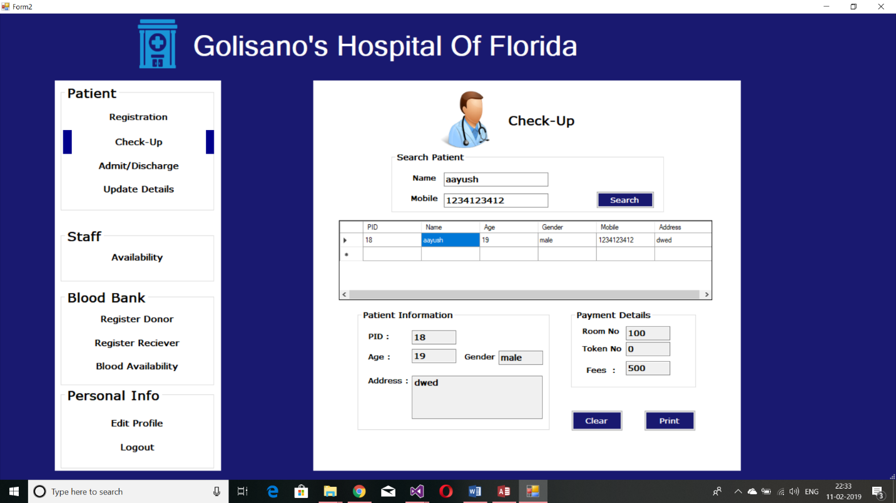

Print button will download payment form

3.3 Admit/Discharge

This page allows the user to admit/discharge a patient. First the user has to search for the patient’s registration on basis of name and contact no.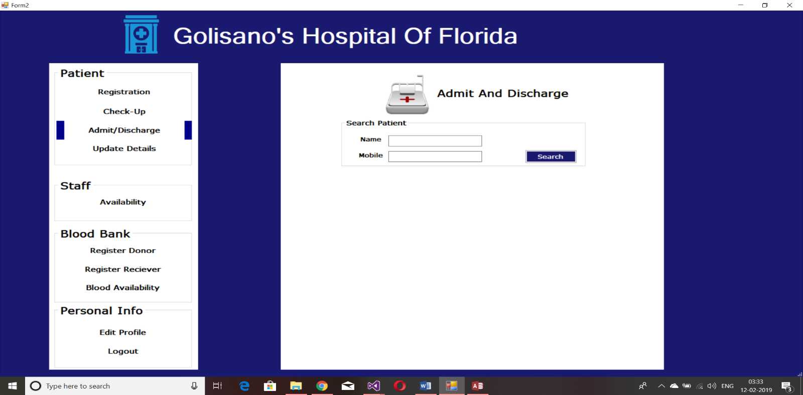

On obtaining the patient info the user needs to click the admit button to get the form for admitting patient.

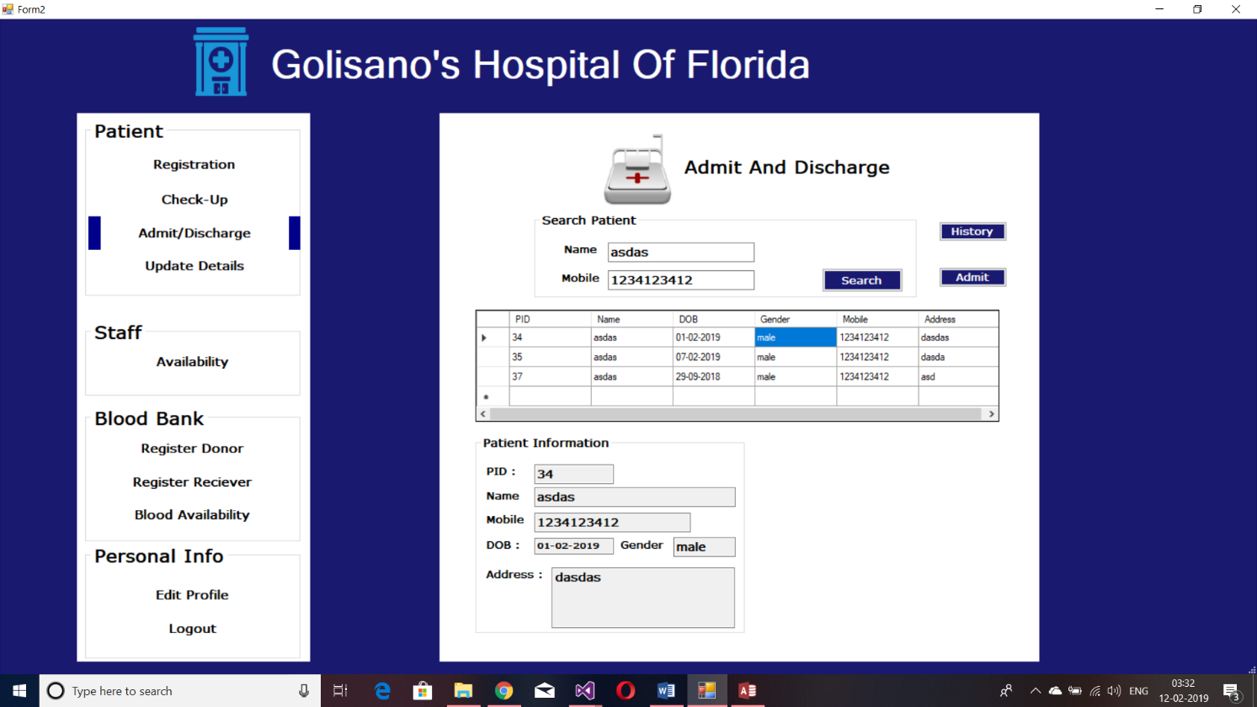

Admit Button

The user will have to enter the date-in/date-out depending on admit/discharge respectively. The history button will show the history of admit/discharge for the patient.

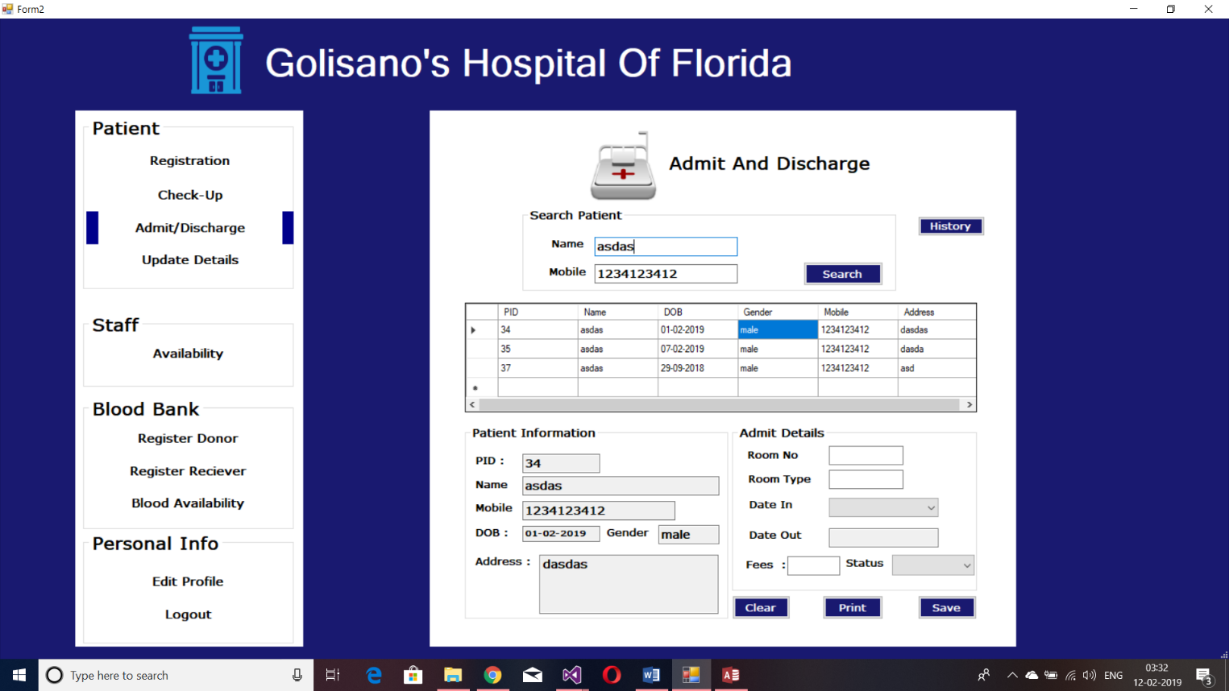

Print Button prints the info from admit form

Admit form

3.4 Update patient details

This page provide the feature to change patients details

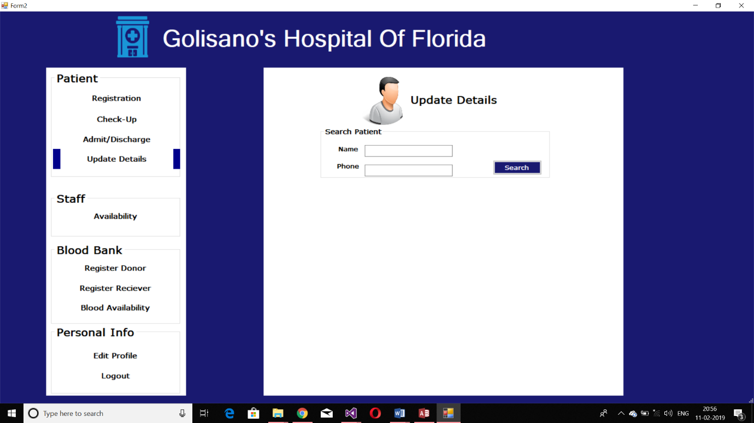

Name of Patient

Update details

Patients Mobile no.

Search button

User has to search patient with his name and phone no. If details are incorrect a message pops up showing “not found”. If details are correct his/her details will be shown in grid view as per the convention mentioned above. And also two buttons are shown update and clear. (User can change details to update the entry).

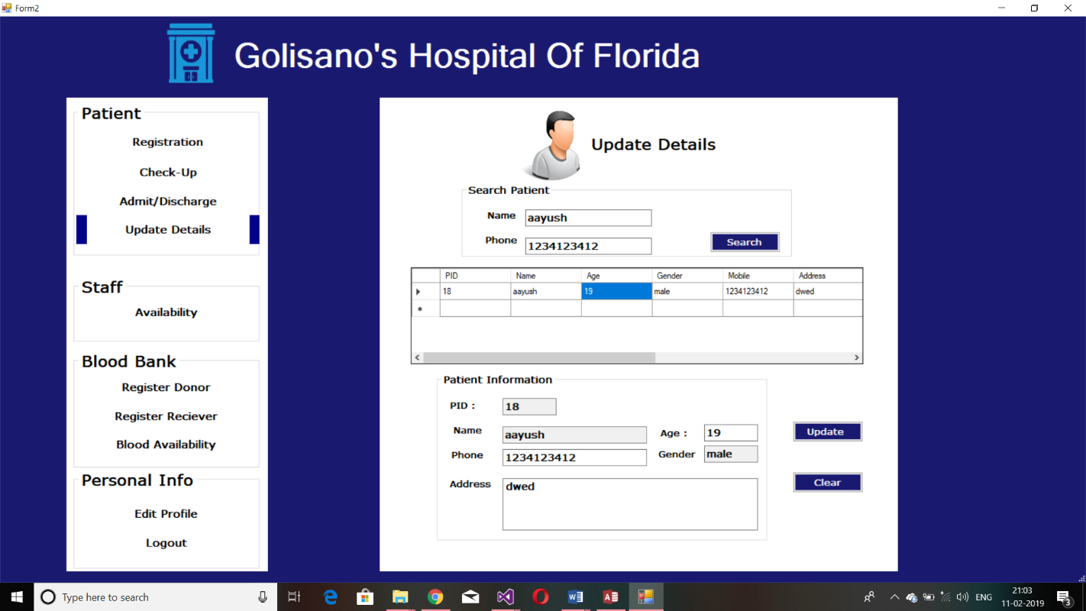

Update Button

When update button is clicked then message pops up saying “updated sucessfully”. Clear button clears the texts.

3.5 Staff Availability

Search button

Designation button(required)

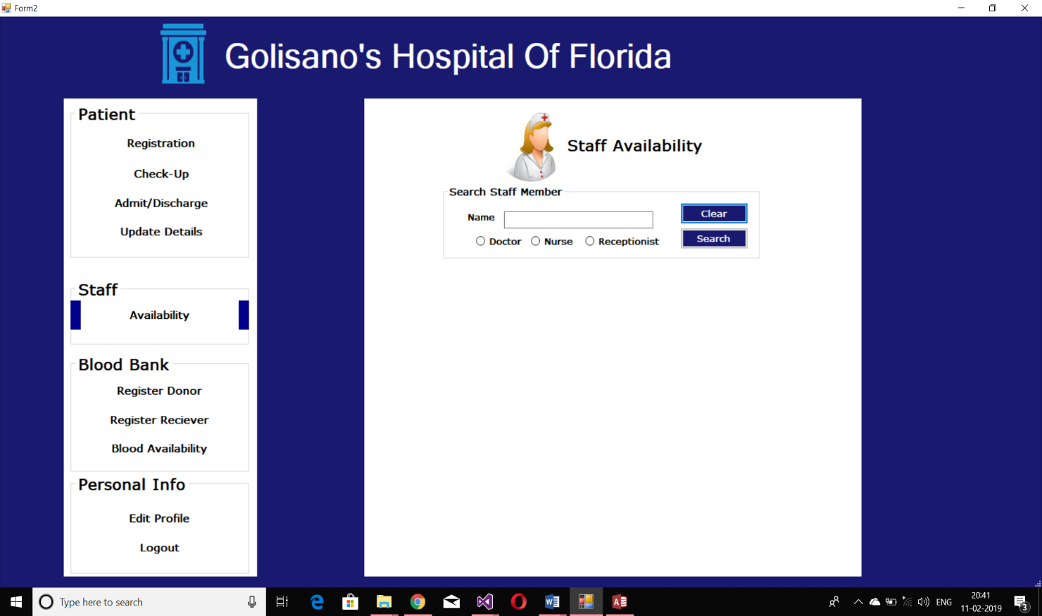 This page provides the details of whether the particular staff is available on duty or not. The user has to search for the staff with his/her name and mobile number.

If the staff doesn’t exist then a pop up message is displayed “Not Found”. Clear button clears the texts.

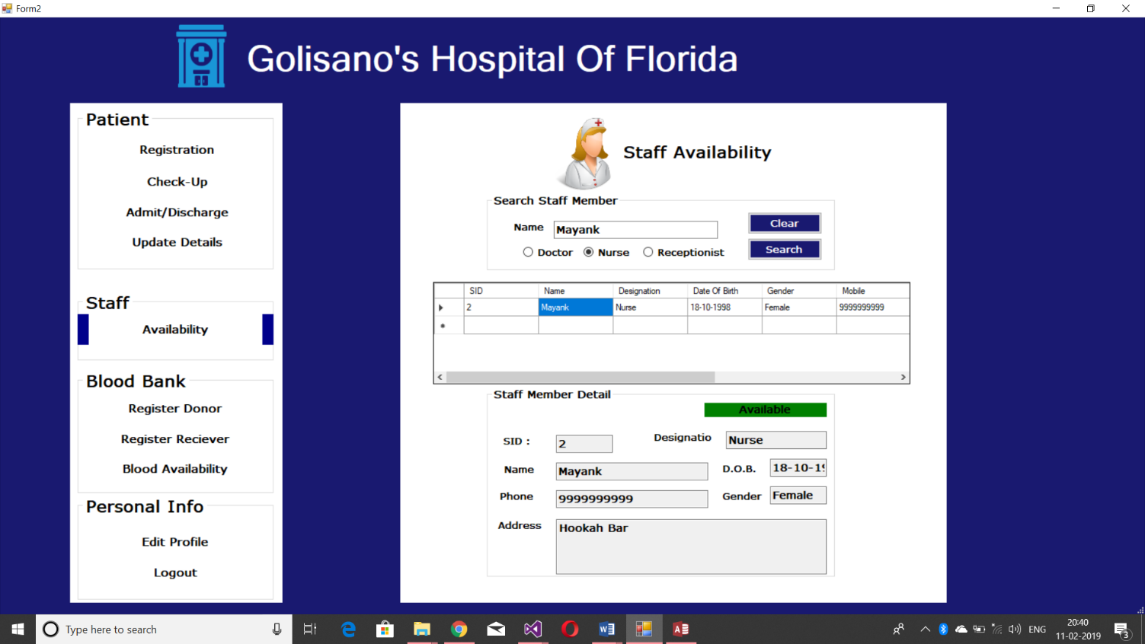

3.6 Register Donor:

Register Donor Page is used to register a donor. This page has some check boxes with some diseases listed.

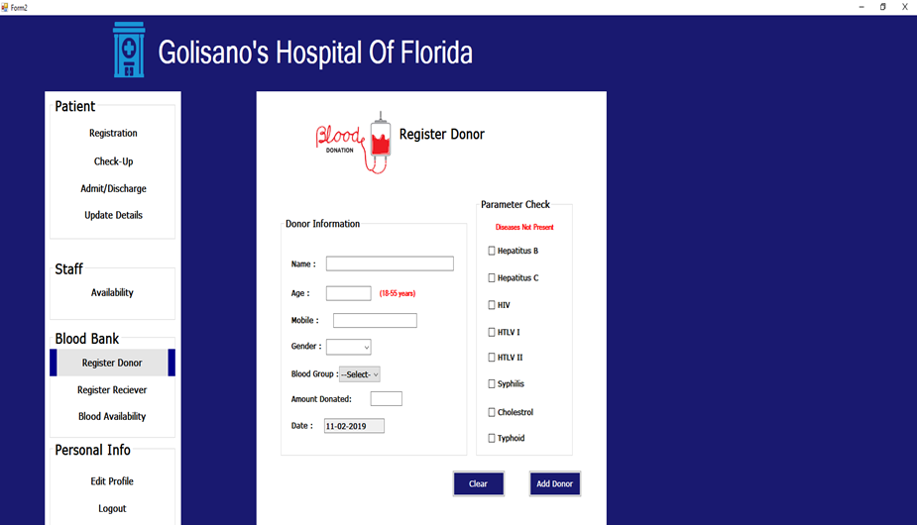

Add donor button

Eligibility test for donating blood (Every checkbox is to be checked to donate)

Tick marked options in parameter check is for ensuring that the donor does not have that disease. Clear button clears all the fields. This page has certain requirements such as age must be between 18-55 years , weight should be above 50 kgs, all check boxes must be ticked,etc.

3.7 Register Receiver:

Register receiver page is used to register a blood receiver.

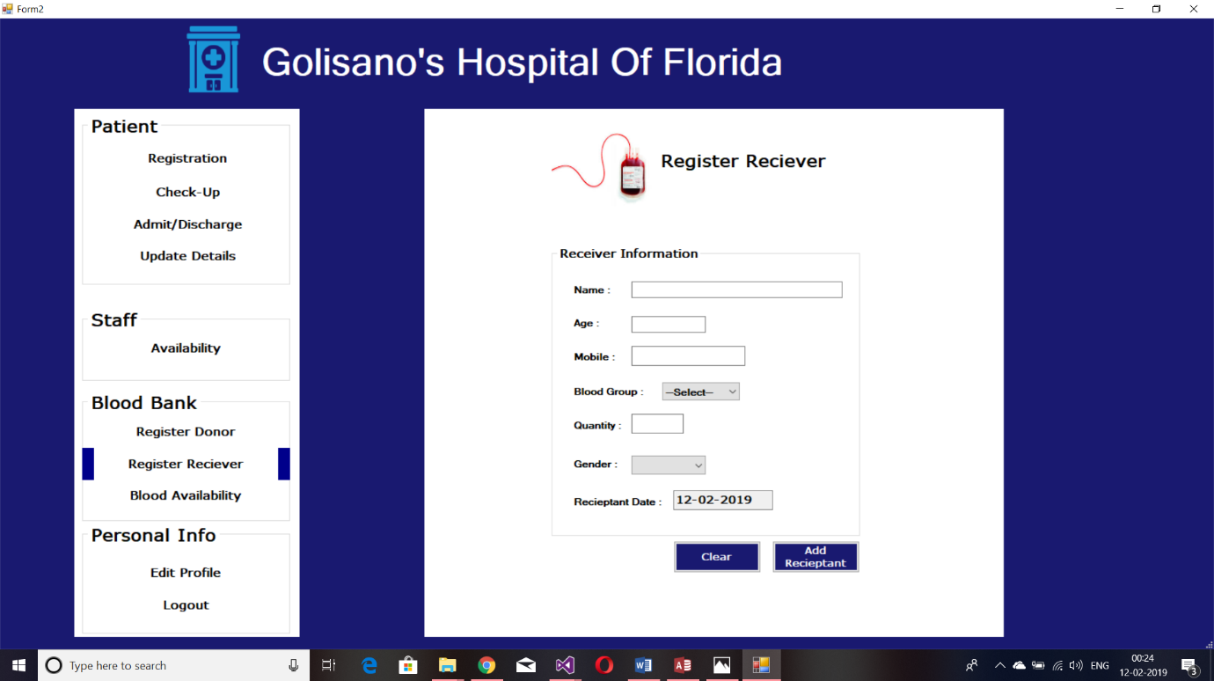

Add Recieptant button

 3.8 Blood Availability:

This page gives the amount of blood available for a particular blood group in litres.

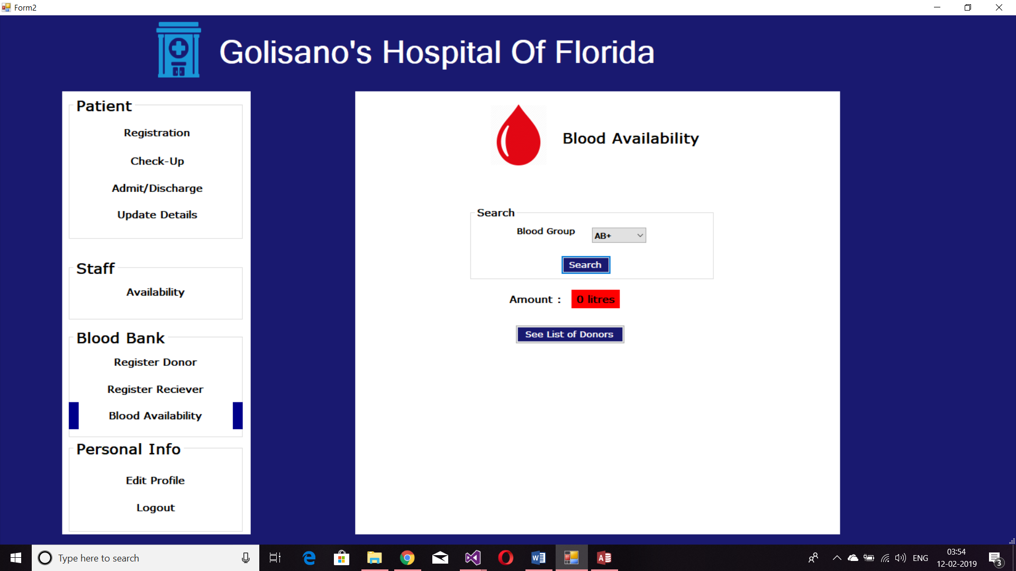

Opens the list of donors of the searched blood group

It also has the feature to show the list of donors of that particular blood group.

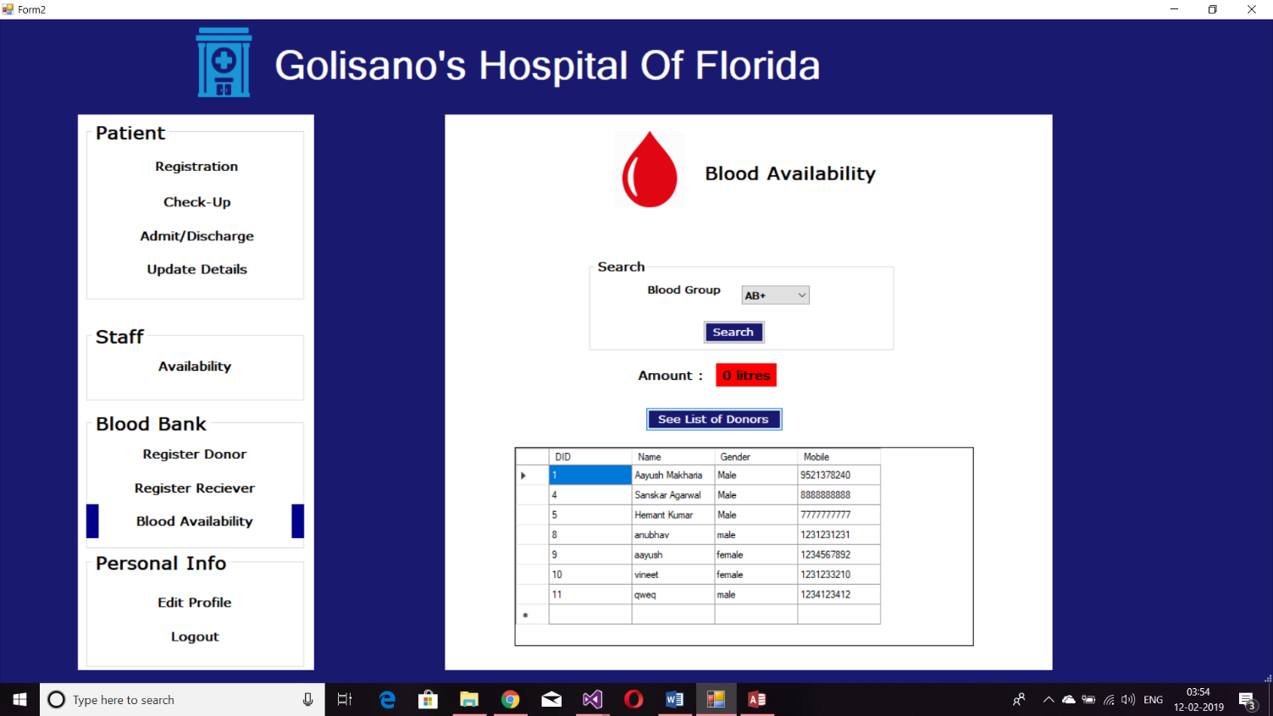

**3.9 Edit Profile**

Edit profile page is used to edit personal information or change password of the profile. For changing password the user needs to enter the old and the new password for updating.

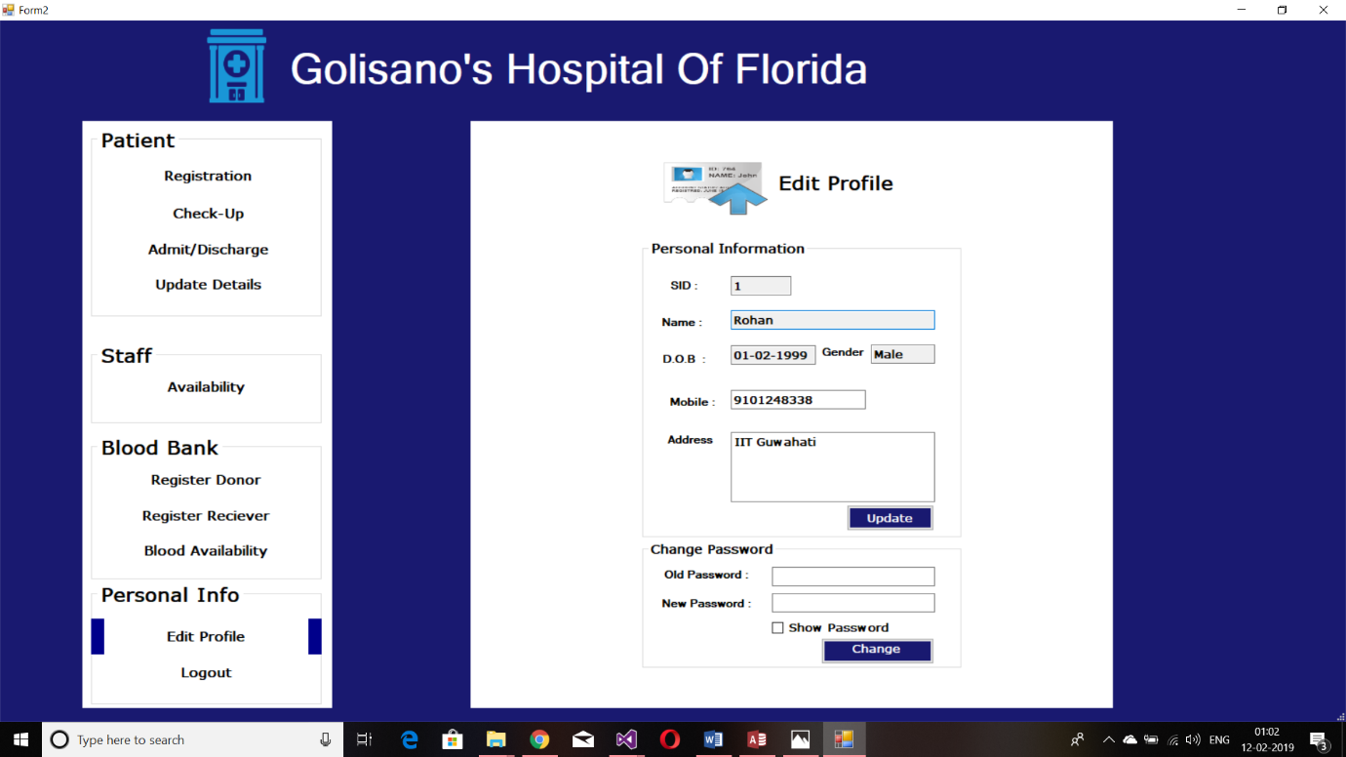

Update button

Change password

4.Admin Login Features…

4.1 Search Patient

This page allows the admin to search for the patient on the basis. After getting the data of a patient as explained at the start, the admin can edit any text on the spot for updating or he/she can delete the entry. The Clear button clears the text. 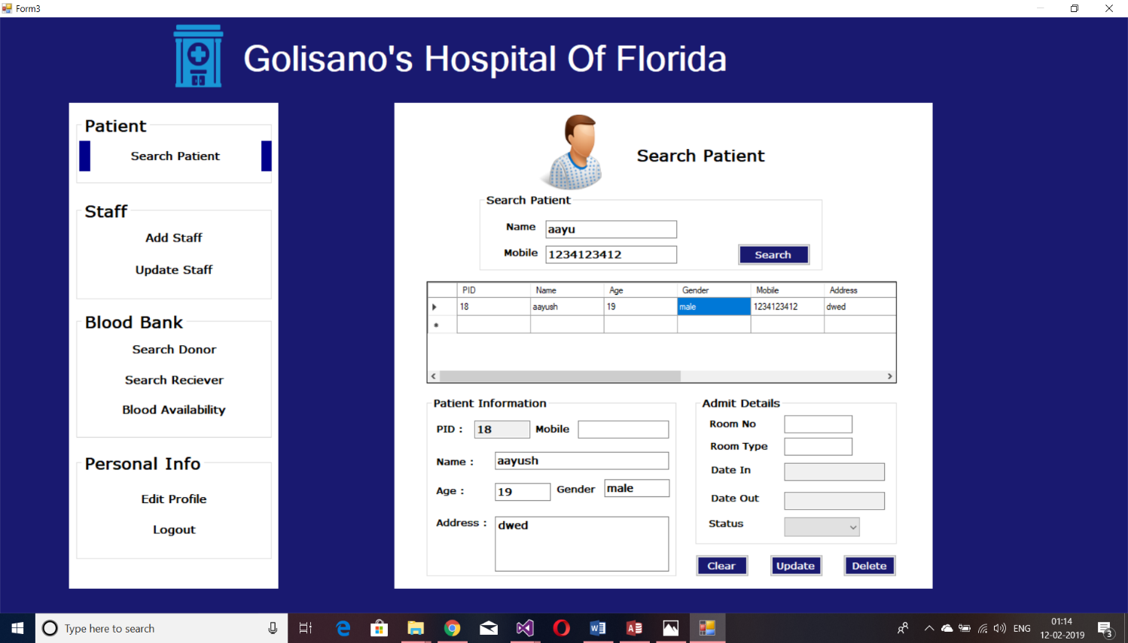

Update button

Delete button

4.2 Add staff

This page provide the feature to add new staff members.

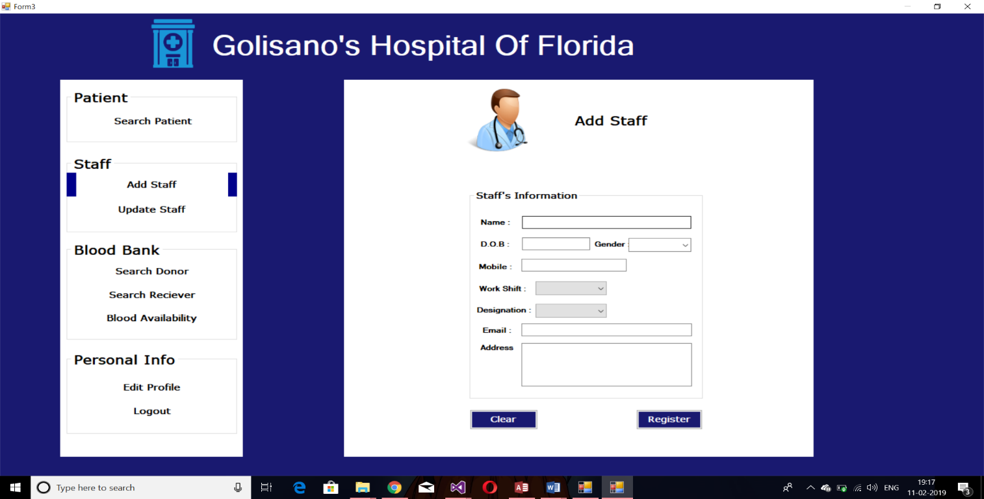

Clear button to clear text

Register button to register

On Entering all valid entries and clicking register sends a mail to the email id consisting of username and password.

4.3 Update Staff

This page provides the feature to update staff details.

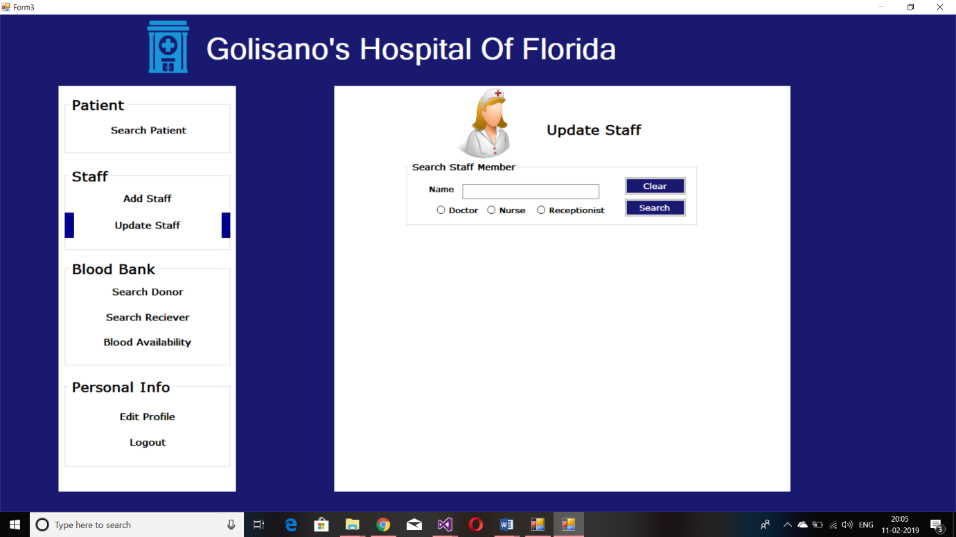

Clear button

Search button

Staff designation

Staff Name

Update staff

First, admin has to search staff details with staff’s name and designation. The shown details follow search convention. The admin can edit any text on the spot for updating or he/she can delete the entry.

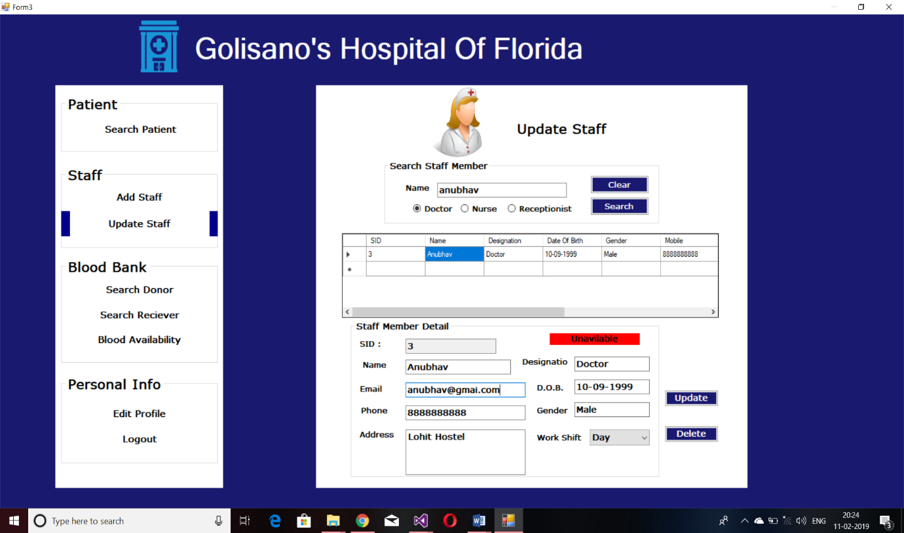

Delete button

Update button

Details of staff

4.4 Search Donor

Search donor page allows the admin to search a donor on the basis of name and contact no.

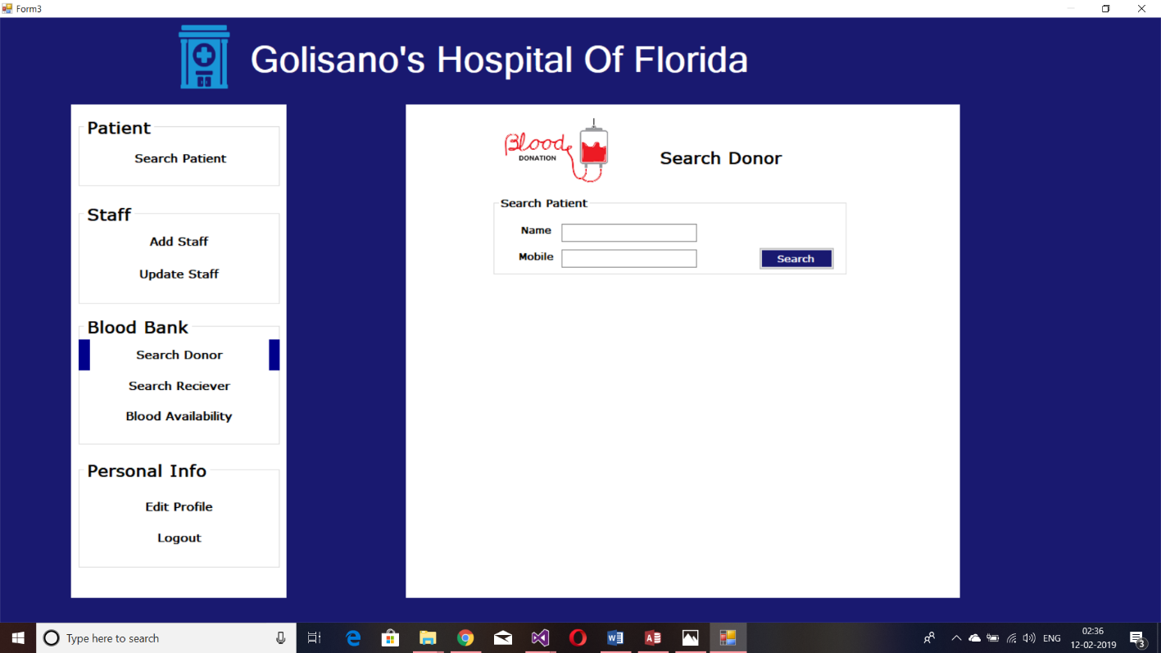

Search Button

The shown details follow search convention. The admin can edit any text on the spot for updating or he/she can delete the entry.

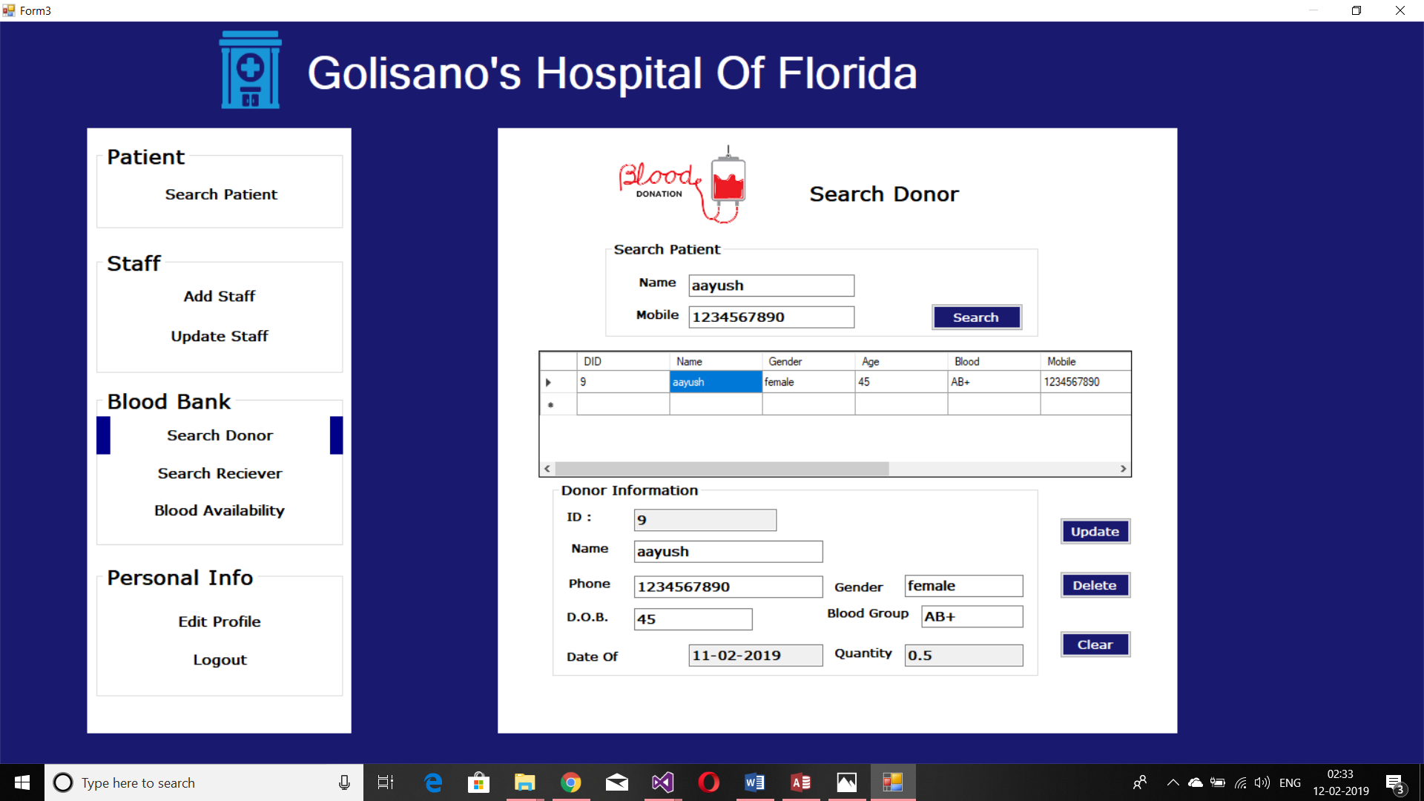

Update button

Delete button

4.5 Search Receiver

Search receiver page allows the admin to search a receiver on the basis of name and contact no.

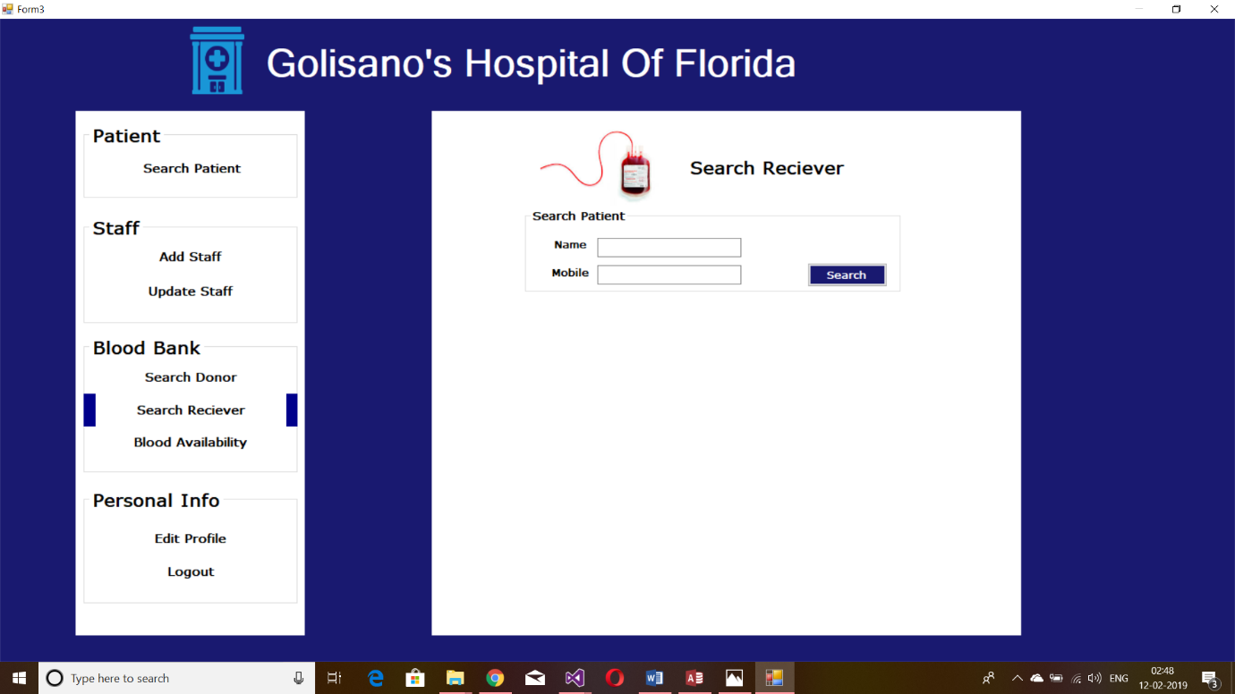

Search Button

The shown details follow search convention. The admin can edit any text on the spot for updating or he/she can delete the entry.

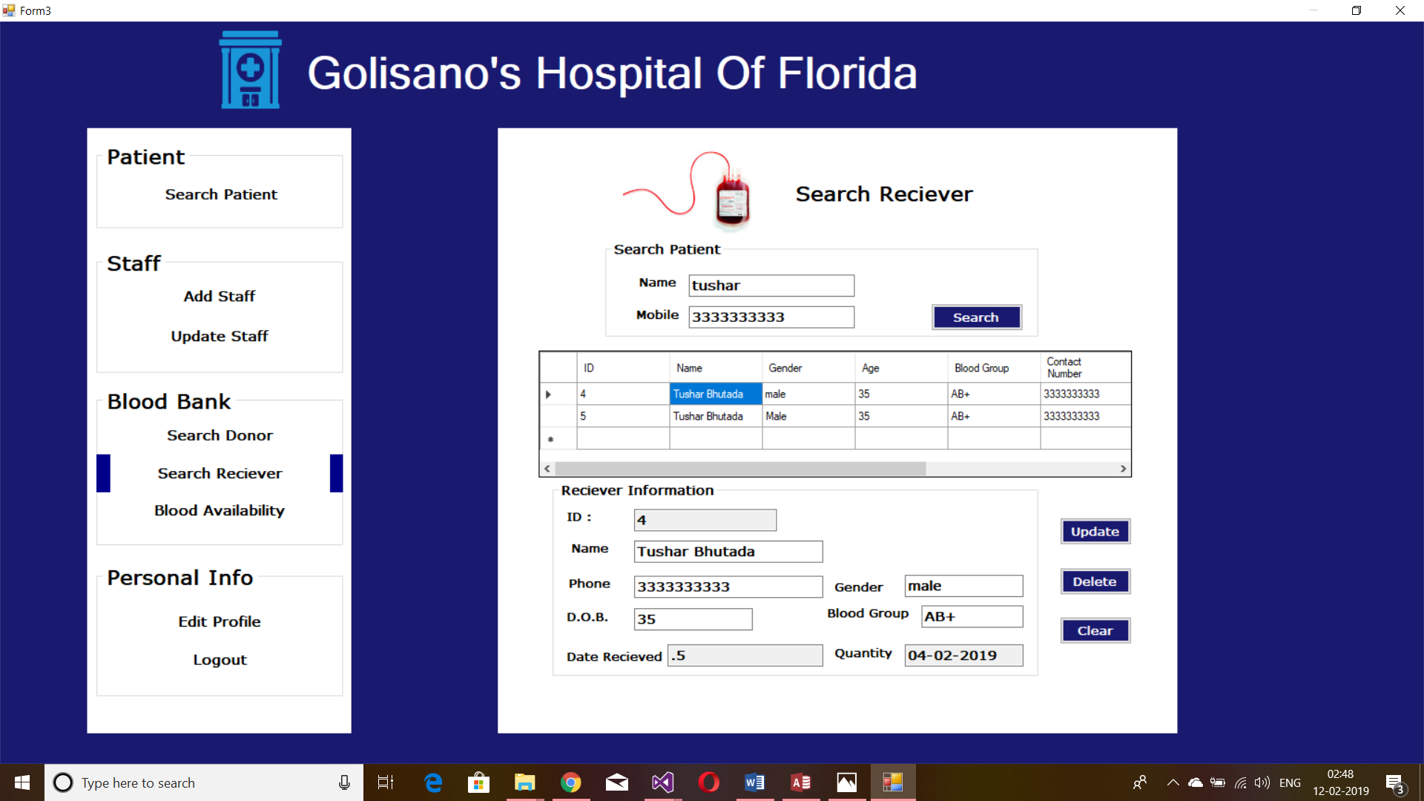

Delete button

Update button

4.6 Blood Availability

This page gives the amount of blood available for a particular blood group in litres. It also has the feature to show the list of donors of that particular blood group.

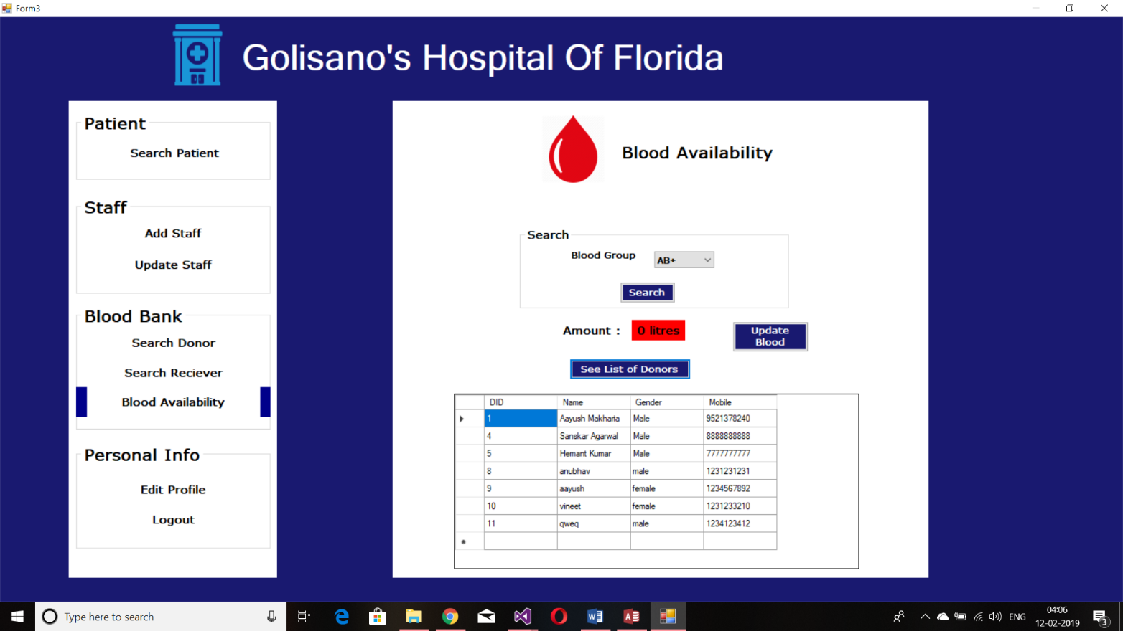

Opens the form for blood updation

If the admin wants to update the amount of blood he/she can click on update button which will open a pop up asking for entering the amount of blood. Thus allowing the admin to control the amount of blood in the hospital.

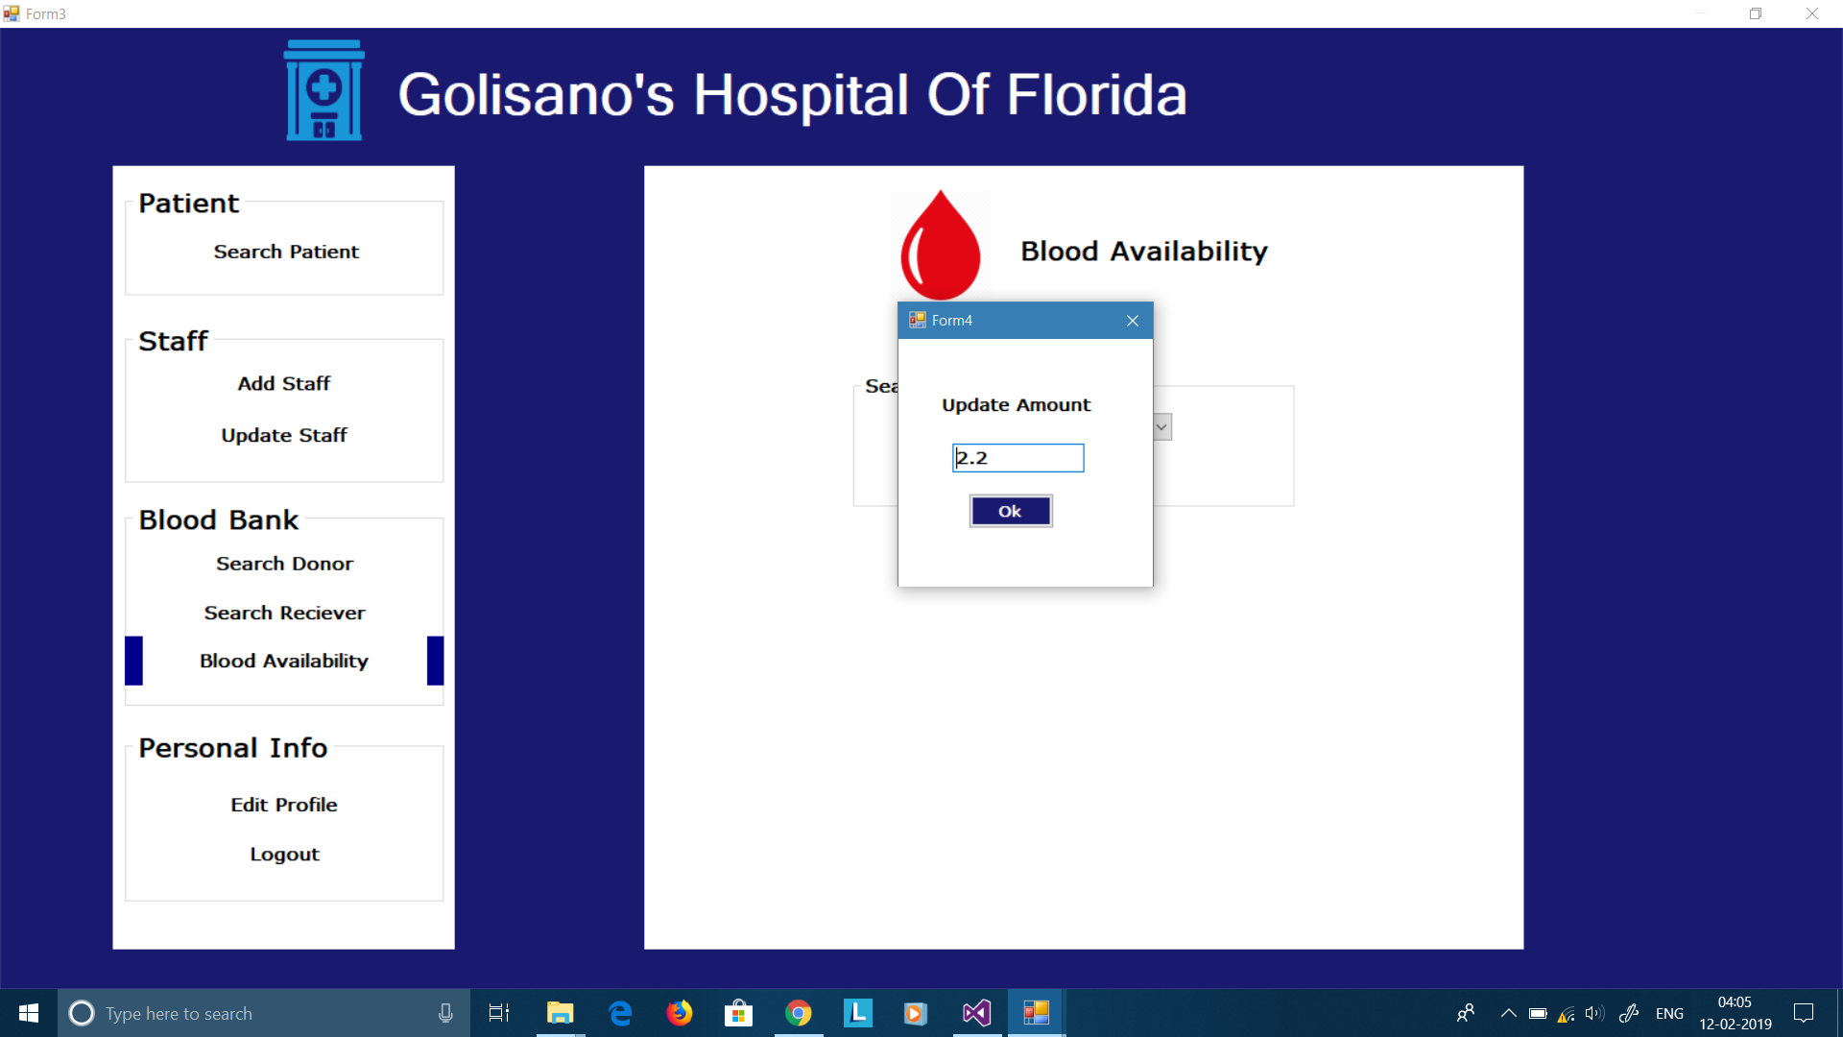

**4.7 Edit Profile**

Edit profile page is used to edit personal information or change password of the profile. For changing password the user needs to enter the old and the new password for updating.

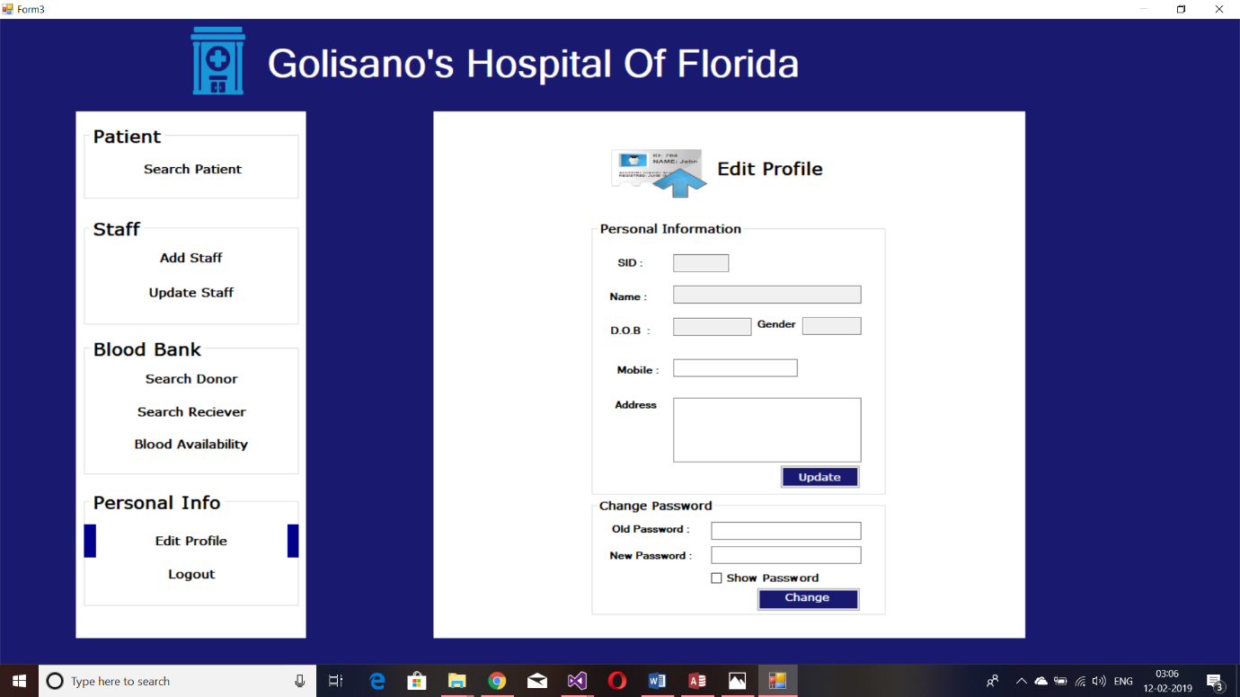

Change password

Update button

5.Logout…

The logout button takes the user back to the login page.

**We hope that you have a smooth and nice experience.**

For queries mail us @ [aayus170101034@iitg.ac.in](mailto:aayus170101034@iitg.ac.in)

[rakes170101071@iitg.ac.in](mailto:rakes170101071@iitg.ac.in)

[tyagi170101009@iitg.ac.in](mailto:tyagi170101009@iitg.ac.in)